CREATE TABLE Inventory_Product (
productId NUMBER PRIMARY KEY,
productName VARCHAR2(100),
quantity NUMBER,
price NUMBER(10,2)
);

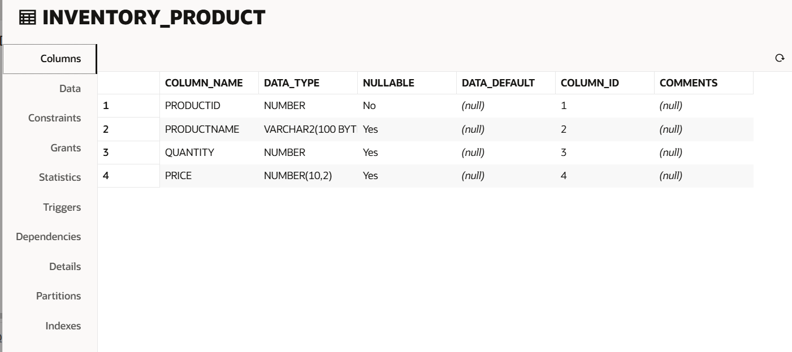

CREATE OR REPLACE PROCEDURE AddProduct(
p_id IN NUMBER,
p_name IN VARCHAR2,
p_quantity IN NUMBER,
p_price IN NUMBER
)
AS
BEGIN
INSERT INTO Inventory_Product
VALUES (p_id, p_name, p_quantity, p_price);
COMMIT;
END;
/

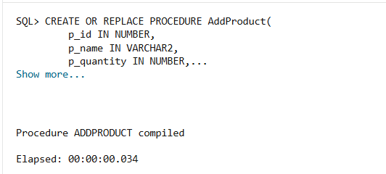

CREATE OR REPLACE PROCEDURE UpdateProduct(
p_id IN NUMBER,
p_quantity IN NUMBER,
p_price IN NUMBER
)
AS
BEGIN
UPDATE Inventory_Product
SET quantity = p_quantity,
price = p_price
WHERE productId = p_id;
COMMIT;
END;
/

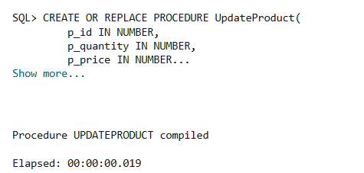

CREATE OR REPLACE PROCEDURE DeleteProduct(
p_id IN NUMBER
)
AS
BEGIN
DELETE FROM Inventory_Product
WHERE productId = p_id;

COMMIT;
END;
/

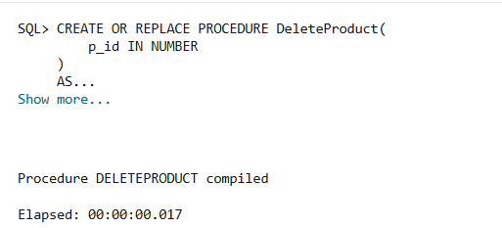

BEGIN
AddProduct(101,'Laptop',20,55000);
AddProduct(102,'Mouse',50,500);
AddProduct(103,'Keyboard',30,1200);
END;
/

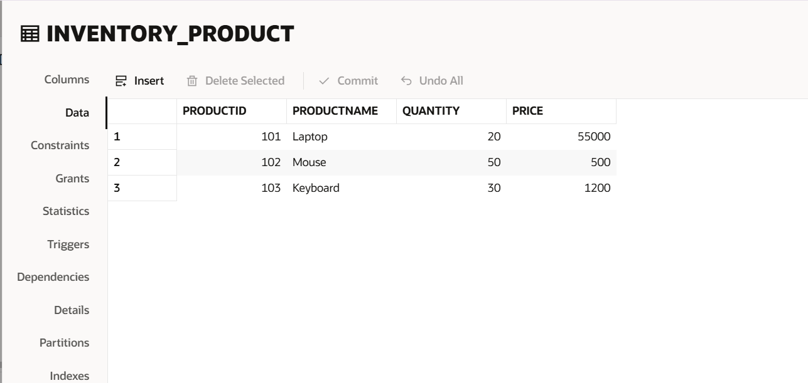

SELECT * FROM Inventory_Product;
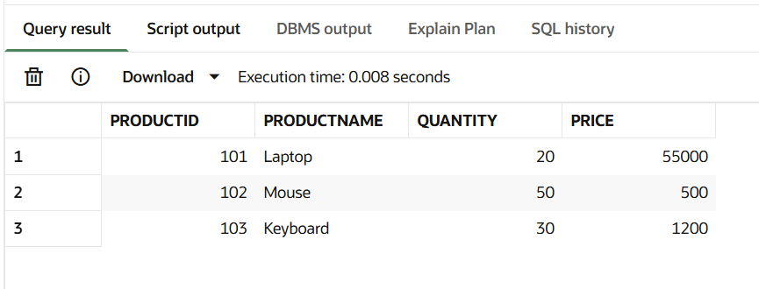

BEGIN
UpdateProduct(102,60,550);
END;
/

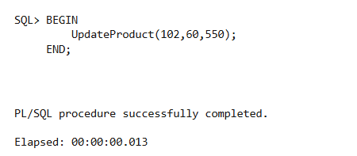

SELECT * FROM Inventory_Product;
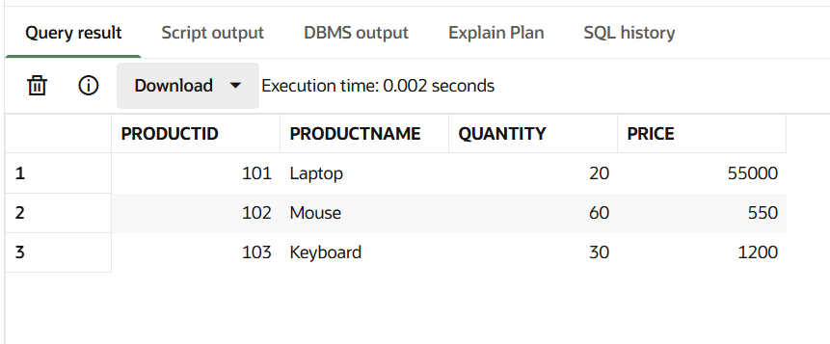

BEGIN
DeleteProduct(103);
END;
/
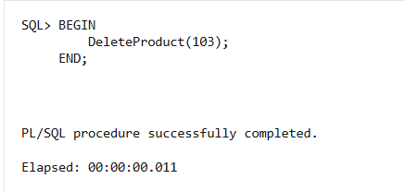
SELECT * FROM Inventory_Product;

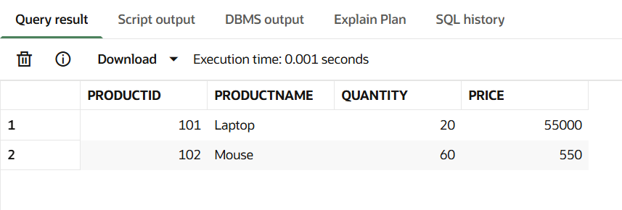

WHOLE CODE
CREATE TABLE Inventory_Product (
productId NUMBER PRIMARY KEY,
productName VARCHAR2(100),
quantity NUMBER,
price NUMBER(10,2)
);
CREATE OR REPLACE PROCEDURE AddProduct(
p_id IN NUMBER,
p_name IN VARCHAR2,
p_quantity IN NUMBER,
p_price IN NUMBER
)
AS
BEGIN
INSERT INTO Inventory_Product
VALUES (p_id, p_name, p_quantity, p_price);

COMMIT;
END;
/

CREATE OR REPLACE PROCEDURE UpdateProduct(
p_id IN NUMBER,
p_quantity IN NUMBER,
p_price IN NUMBER
)
AS
BEGIN
UPDATE Inventory_Product
SET quantity = p_quantity,
price = p_price
WHERE productId = p_id;

COMMIT;
END;
/

CREATE OR REPLACE PROCEDURE DeleteProduct(
p_id IN NUMBER
)
AS
BEGIN
DELETE FROM Inventory_Product
WHERE productId = p_id;

COMMIT;
END;
/

BEGIN
AddProduct(101,'Laptop',20,55000);
AddProduct(102,'Mouse',50,500);
AddProduct(103,'Keyboard',30,1200);
END;
/

SELECT * FROM Inventory_Product;

BEGIN
UpdateProduct(102,60,550);
END;
/

SELECT * FROM Inventory_Product;

BEGIN
DeleteProduct(103);
END;
/

SELECT * FROM Inventory_Product;

